

COMP-8677

Networking and Data Security

LAB 6 Report

Professor

Dr. Shaoquan Jiang

Karan Vishavjit

Student Id: 110099867

**Part I (create server public-key and its certificate)**

In TLS, the server must have a RSA public key. To guarantee this public key is owned by this

server, it must be certified by an authority. In reality, this is done by some special company such

as VeriSign. In our experiment, we ourselves will play the role of an authority. This authority will

generate its own public/private key and certificate (which is a self-signed signature), just as

what a real root CA has done. It then will generate the certificate for the TLS server. The task

can be done by following the following procedure.

1. Copy /usr/lib/ssl/openssl.cnf to your current working directory and make the following

change to this file:

"policy = policy_match" to "policy = policy_anything"

/*this allows the CA to generate certificate for more potential users. */



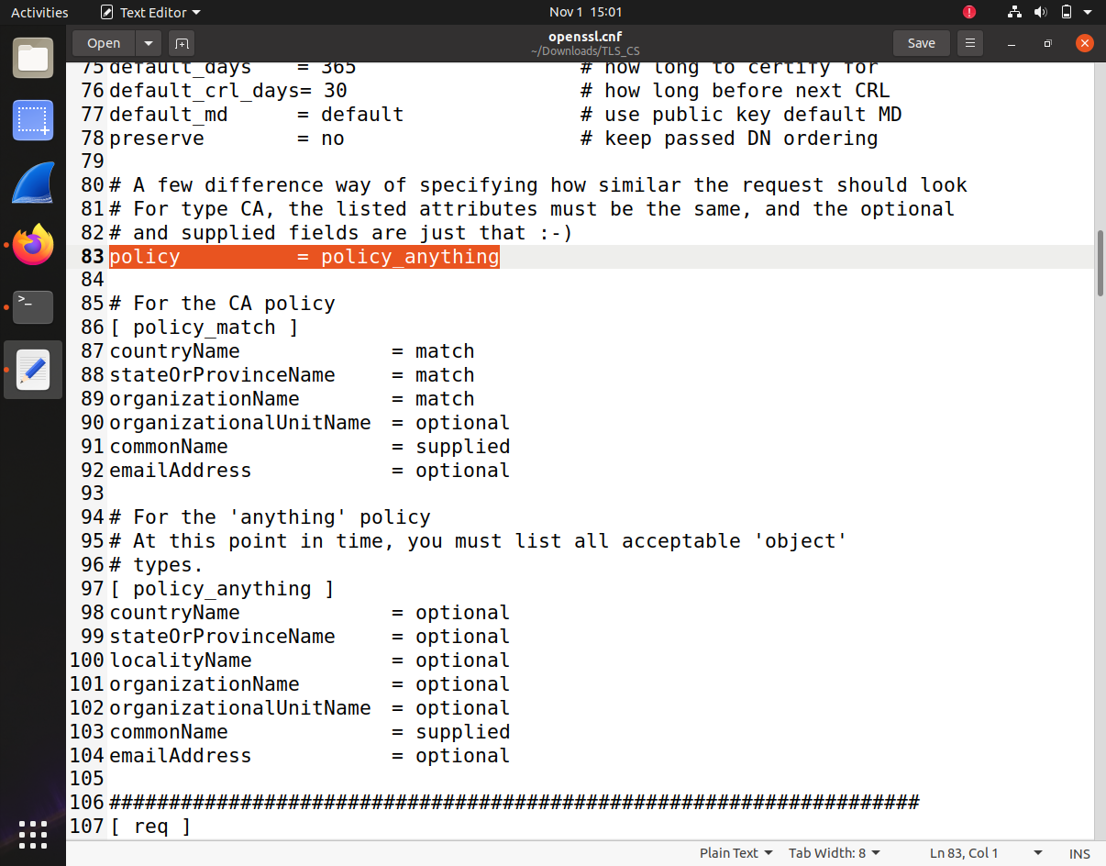

1. Create a new directory **demoCA** in the current directory. Then, do the following.
   * Create new directories **certs, crl** and **newcerts** in demoCA and empty files index.txt and serial. Put a single serial number (.e.g., 1000) in the file serial.

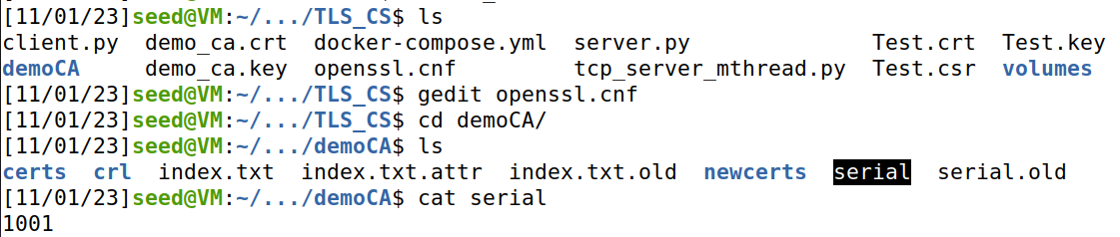

* + Generate a self-signed certificate for our certificate authority (CA).

**$openssl req -new -x509 -keyout demo_ca.key -out demo_ca.crt -config openssl.cnf -days 365**

/* **demo_ca.key** has private RSA key for CA; **demo_ca.crt** is its self-signed certificate with 365 days validity. */

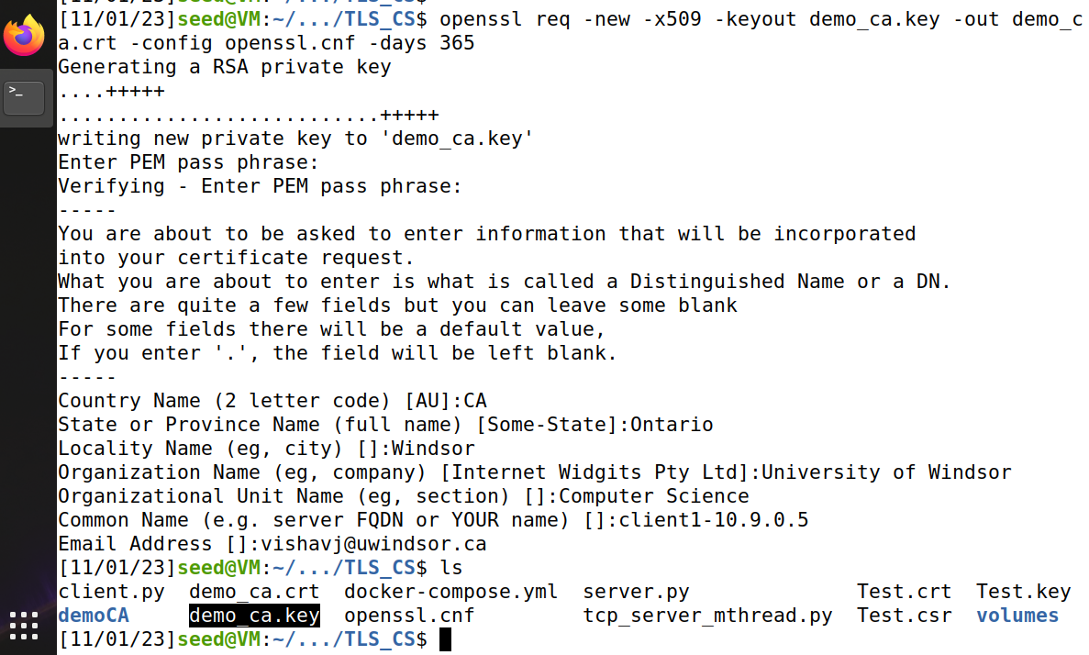

* + Create a certificate for our test TLS server, signed by our authority’s key demo_ca.key.

1. Generate a RSA private key for TLS server.

**$ openssl genrsa -aes128 -out Test.key 2048**

/*To view the file, $openssl rsa -in Test.key -noout -text */

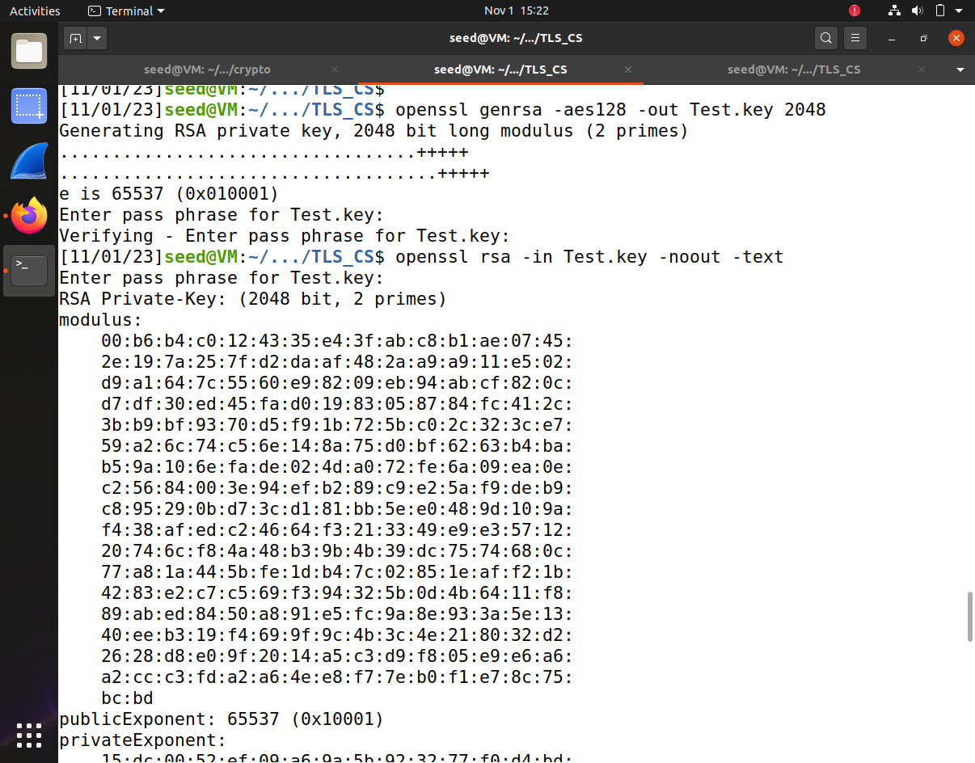

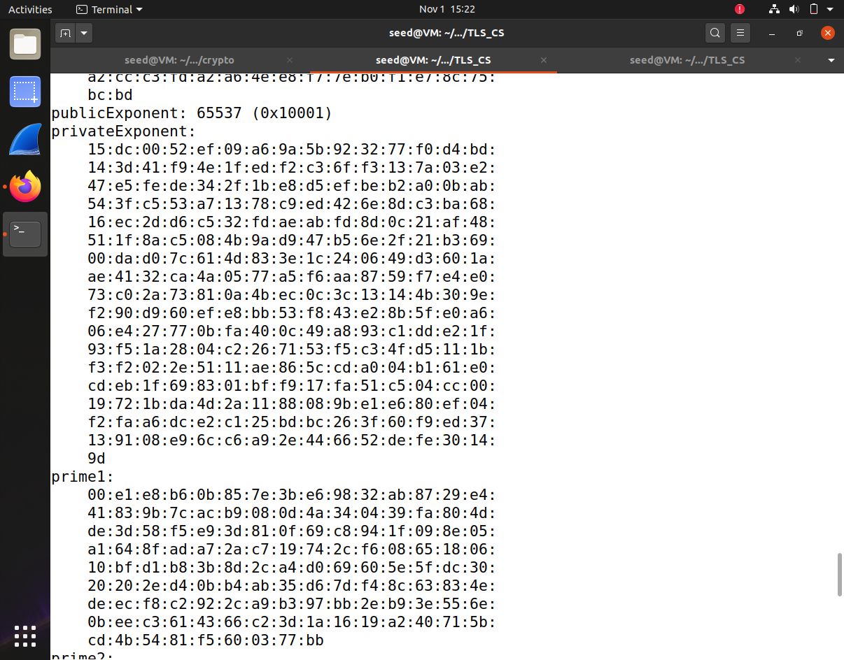

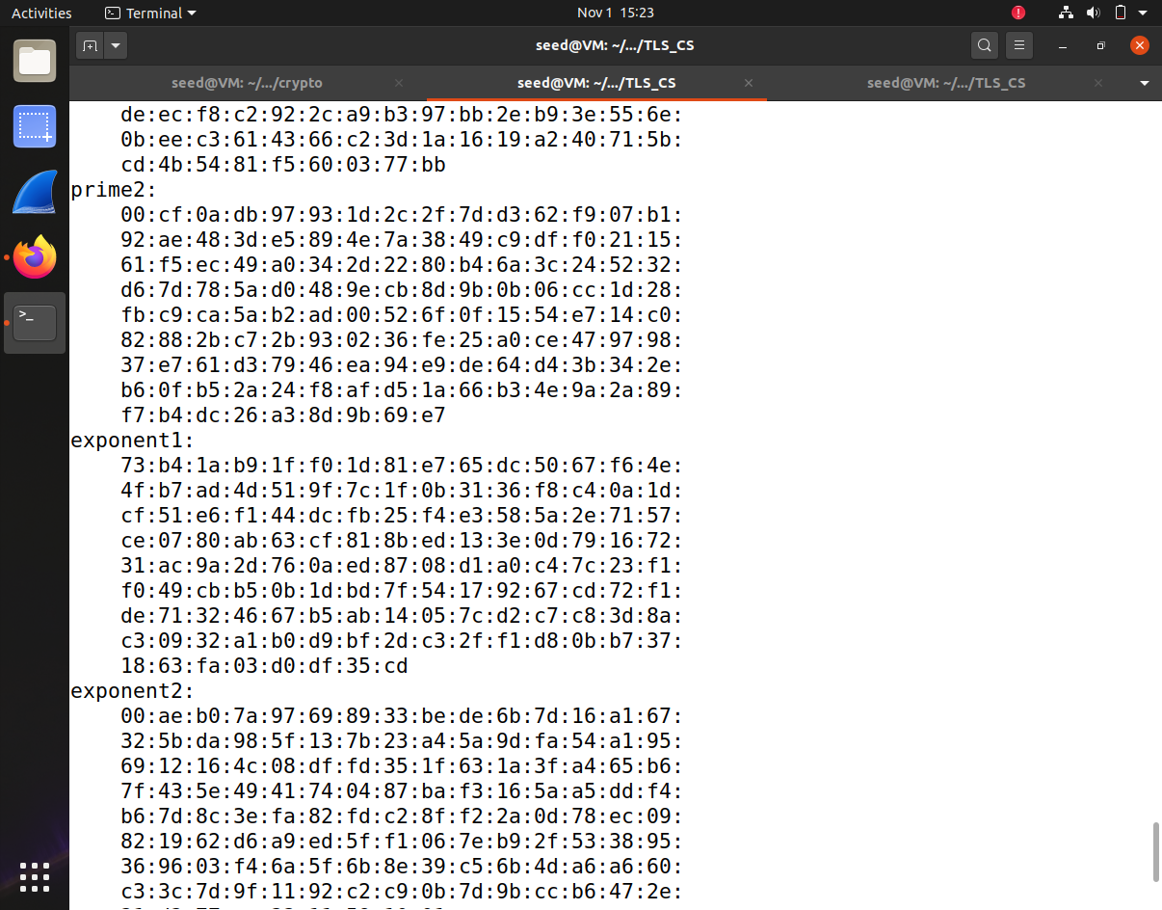

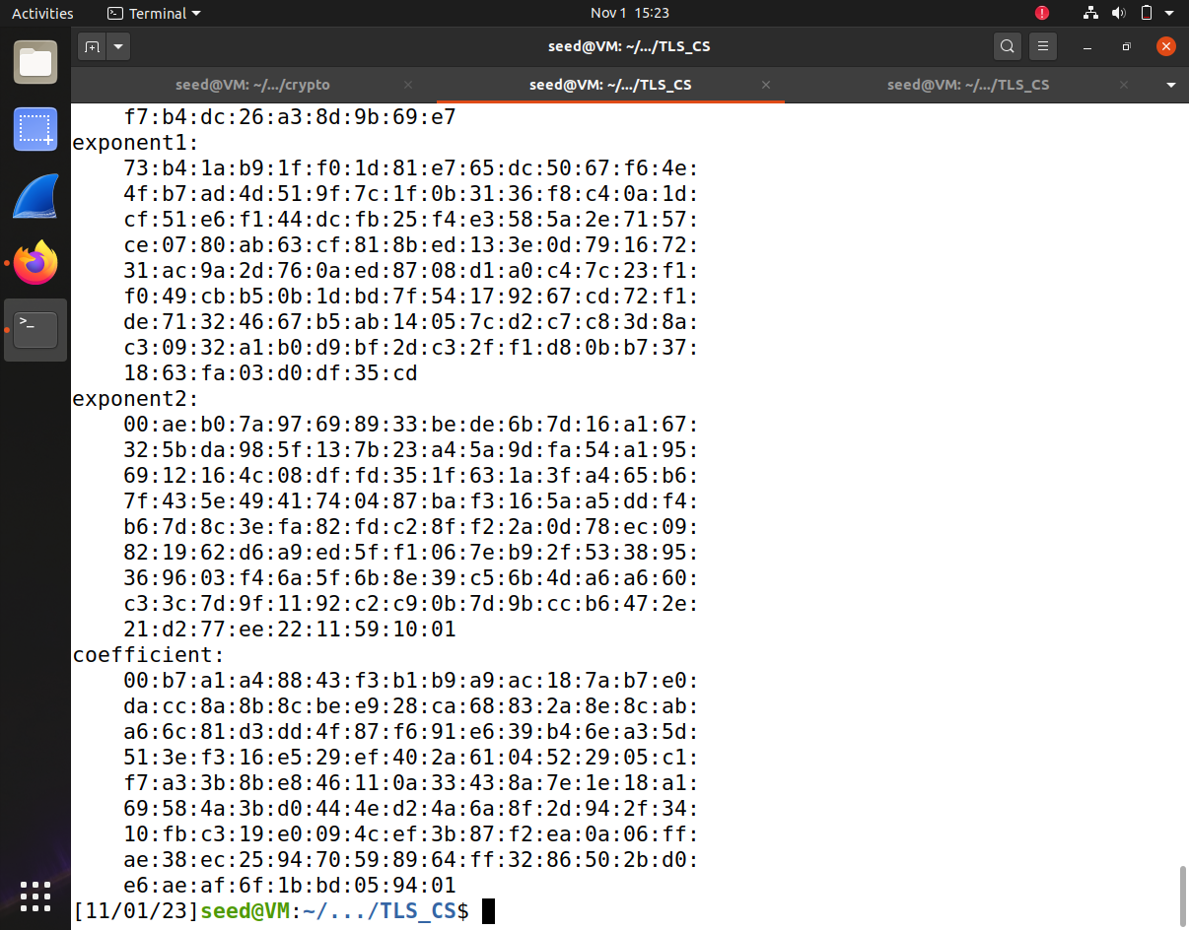

1. Generate a certificate signing request:

**$ openssl req -new -key Test.key -out Test.csr -config openssl.cnf**

/* this generates a certificate request so that CA can sign a cert for TLS server:

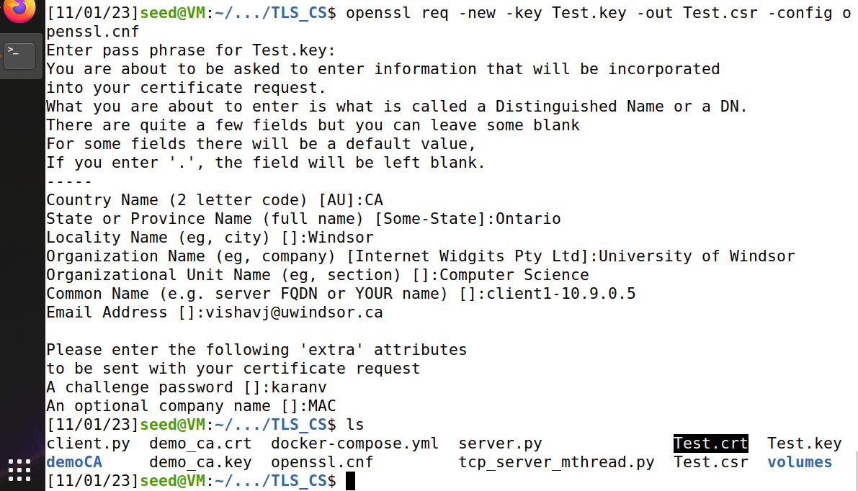

1. Generate the certificate for TLS server:

**$ openssl ca -in Test.csr -out Test.crt -cert demo_ca.crt -keyfile demo_ca.key -config openssl.cnf**

/*Test.crt is the certificate for TLS server */

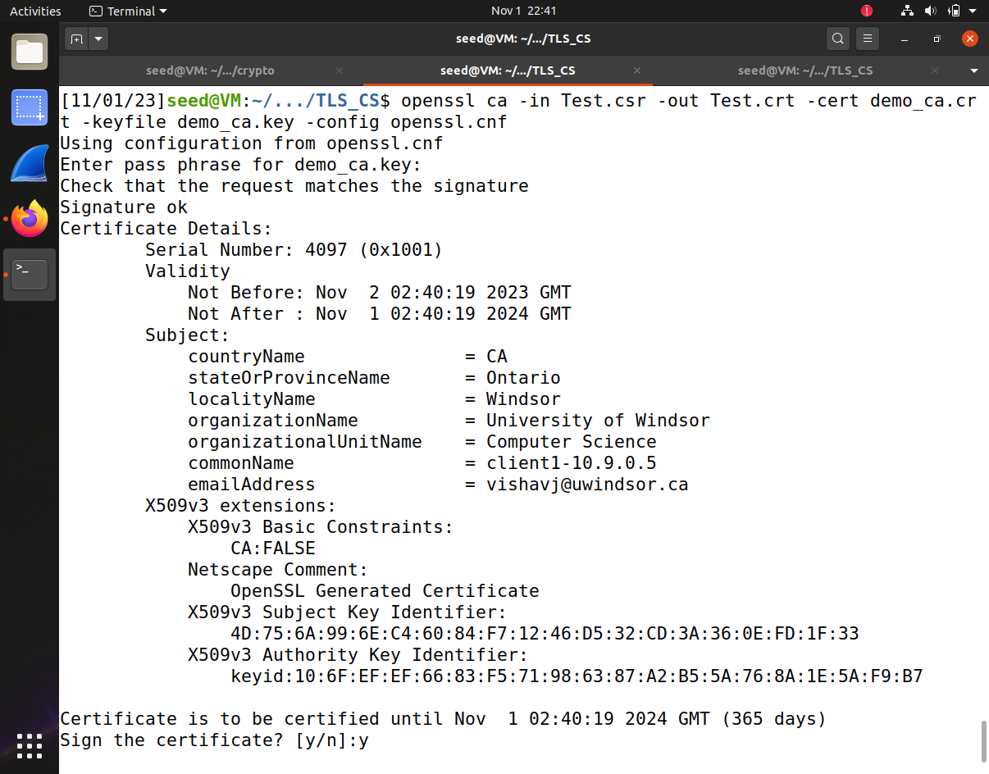



1. Copy your certificate Test.crt and Test.key to a folder certS in the shared folder volumes (your server program such as server.py will send Test.crt to client and use Test.key to decrypt or sign a document).

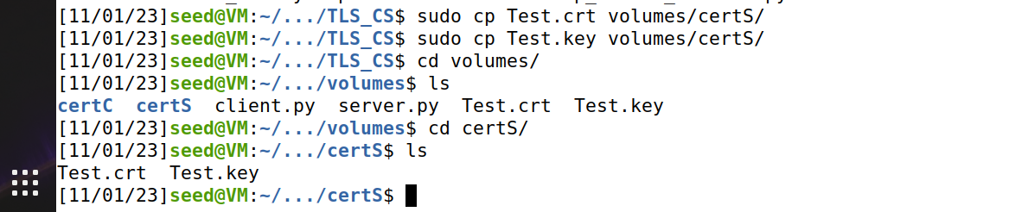

1. Copy demo_ca.crt to folder (such as certC) in the shared folder volumes. Later your client program (such as client.py) will use this demo_ca.crt to verify if the server certificate Test.crt is indeed owned by your server VM. However, your client VM cannot directly locate demo_ca.crt. You need to create a symbolic link that links to demo_ca.crt. Your client VM can use this symbolic link to find demo_ca.crt in certs.



* + 1. **openssl x509 -in demo_ca.crt -noout -subject_hash**



* + 1. **ln -s demo_ca.crt 8f838d2e.0**



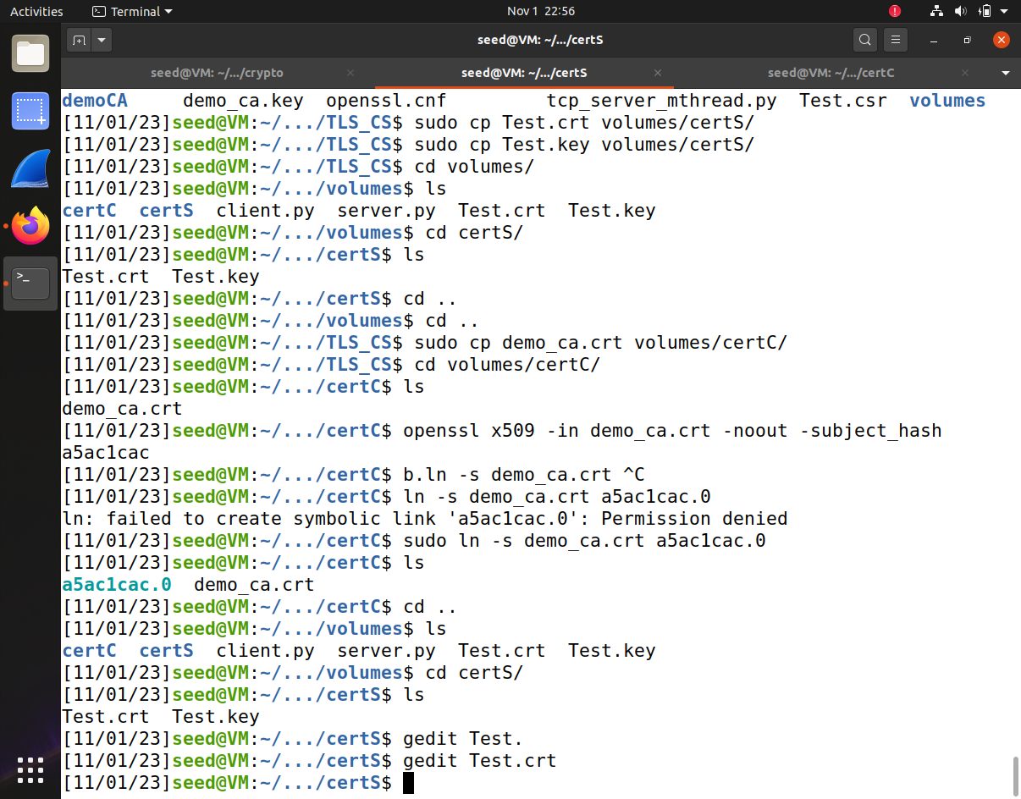

**Part II. (TLS Client and Server Communication)**

In this part, you need to create a TLS server and TLS client with some functions. Toward this, you are encouraged to run the provided TLS server and client to get familiar with how TLS client and server can be connected.

* **Step 1.** Make sure that Part I has been done.
* **Step 2.** Use the provided **client.py** and **server.py**. Modify the certificate directory **cadir** in server.py to make sure it is the directory **certS** for the server certificate and server private key directory (in Part I). Also modify the certificate directory **cadir** in client.py to make sure that it is the directory **certC** of the CA’s certificate demoCA.crt.
* **Step 3.** Run .$sudo python3 server.py on the server VM (should be the same as in Test.crt)
* **Step 4.** Run client.py with server container name (e.g., client1-10.0.2.5):

$ python3 client.py client1-10.9.0.5

Then, if you receive the response from server, then you are done

**Server Connection:**

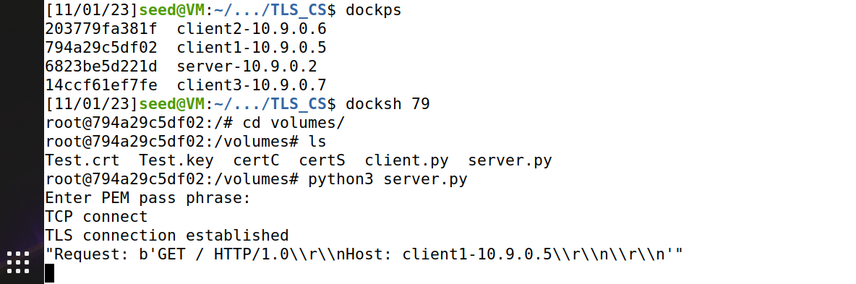

**Client Connection:**

